Entry number: 1
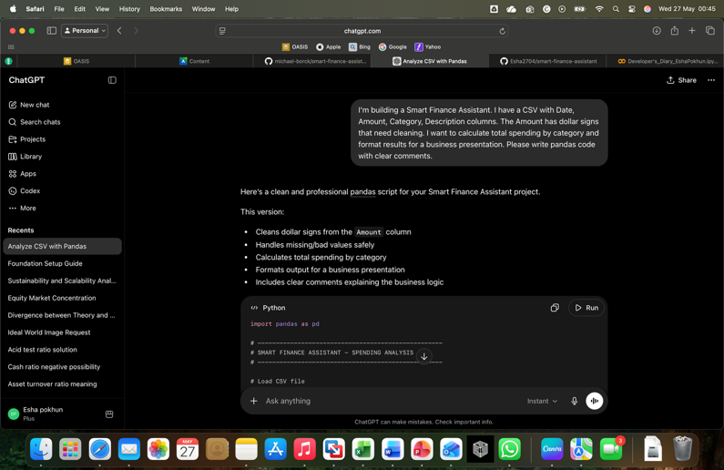

Artifact:

Context: I wanted to clean transaction data and calculate total spending by category for my Smart Finance Assistant.

My Prompt: “I'm building a Smart Finance Assistant. I have a CSV with Date, Amount, Category, Description columns. The Amount has dollar signs that need cleaning. I want to calculate total spending by category and format results for a business presentation. Please write pandas code with clear comments.”

AI Response Summary: I'm building a Smart Finance Assistant. I have a CSV with Date, Amount, Category, Description columns. The Amount has dollar signs that need cleaning. I want to calculate total spending by category and format results for a business presentation. Please write pandas code with clear comments.

My Critique/Improvement: I improved the AI-generated solution by handling missing values and checking for refund transactions with negative amounts.

Result: I successfully created a spending analysis system that grouped transactions into categories and generated meaningful financial summaries.

Reflection: I learned that business data often contains messy formatting and edge cases like refunds. Providing detailed business context to AI generated more professional and usable code solutions.
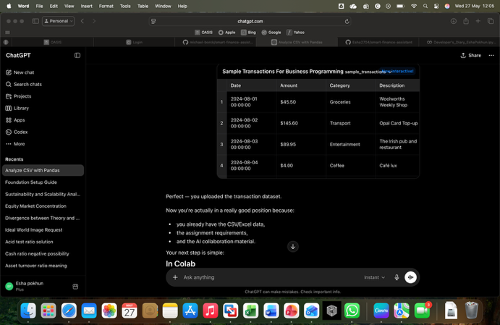
Entry number: 2
Artifact:

Context: I wanted AI to analyse my CSV transaction so that it can reduce my workload throughtout my assignment.

My Prompt: “wait, for the csv transaction, I have a list. Do I send you?”

AI Response Summary: AI has helped me generate my python code for my smart financial insights.

My Critique/Improvement: While entering my prompts, I had to make sure that I have modified my CSV transaction and not the one given in Colab.

Result: I have successfully loaded finance data and cleaned all the messy dollar signs so that pandas can calculate the total properly.

Reflection: I have learned that pandas cannot calculate total while the dollar signs exist, so removing the dollar signs then run the code is more approriate to get best results.

